Assignment 14

Name-pratiksha Ravindra katkar.

College-S.P.M.M.Satara

Batch Code-SDA XT J88

Roll no-3082

Date-3/9/2024

Q1) Create package geometry with two class Rectangle and Triangle import those classes in your package

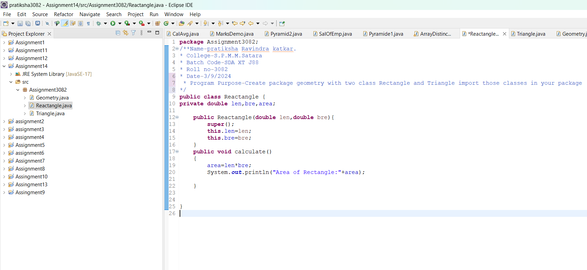

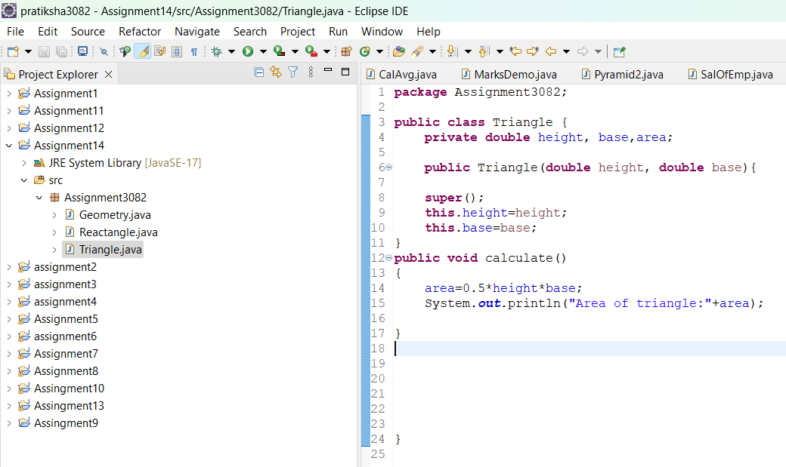

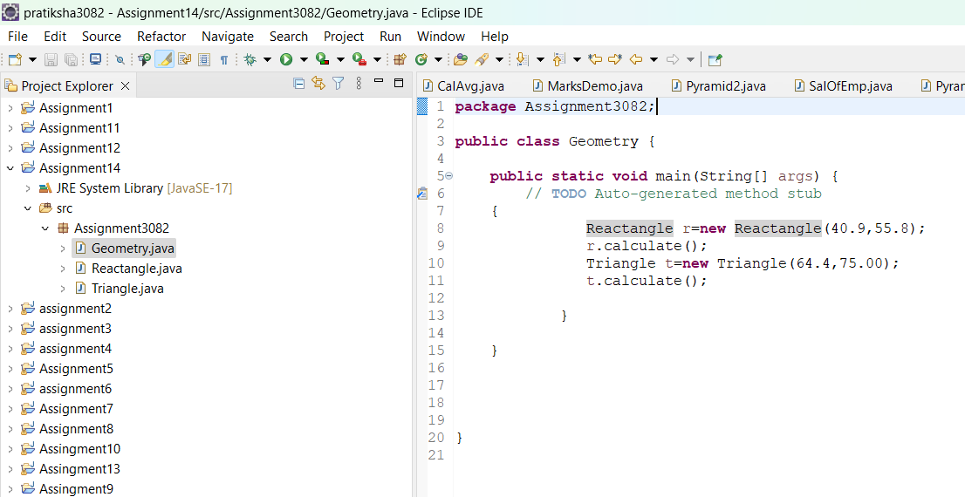

Output:



Q2)

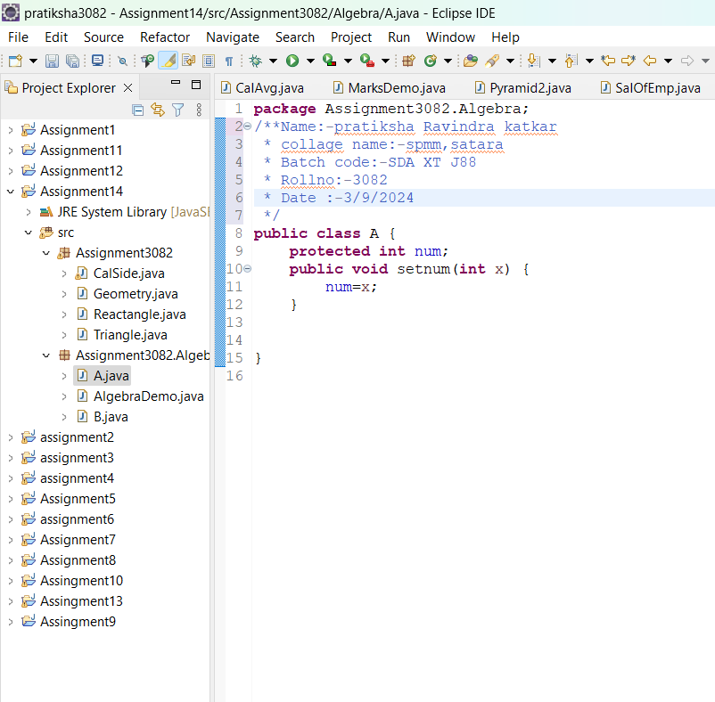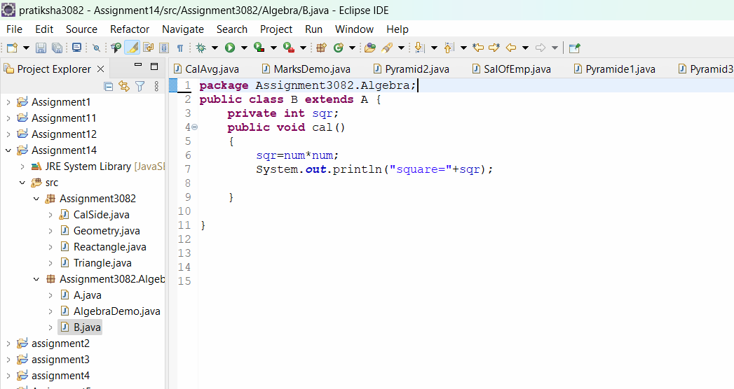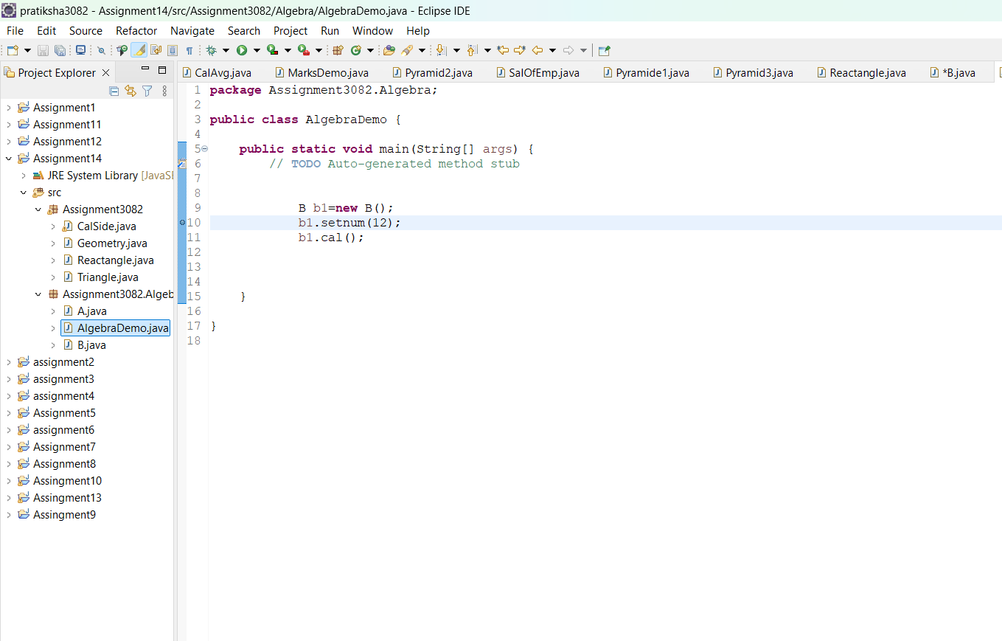

Output:



Q3) write a program to calculate side triangle using law of cosine use static import for mathematical function. 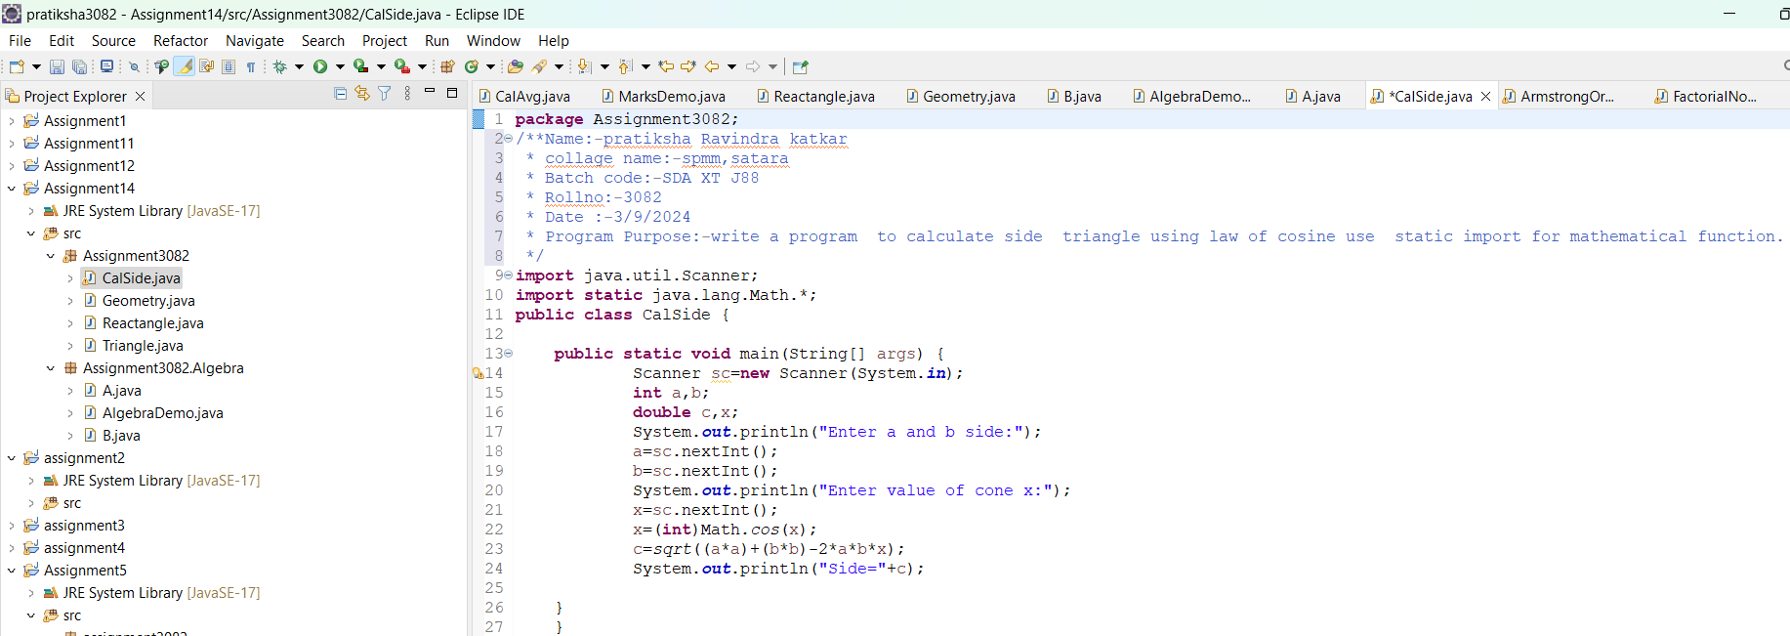

Output:

